**Database 3 labs**

Section 1: start with a single VM with Windows OS installed, plus latest install programs(zips) for MySQL (Server & clients), plus sample databases (in text or comma delimited form). Students perform installation, configuration & migration. You must be able to execute SQL in both command line and GUI clients to imported databases on servers you have installed and configured.

Step by step guides should be available for most of the tasks. However, some tasks will require you in research a solution. But note, the VM is not connected to the Internet, therefore you will have to ‘swap out’ to the host OS to access a browser program and network connection.

As you attain these tasks/skills call the lecturer and post task completion/comments on the Lab task log on Blackboard.

So starting with the supplied VM with Windows 7 installed. Find and install

* Install MySQL server and clients (Mysql community edition 5.x server (DBMS))

On the install updates page: Select Skip check for updates (as our vApps have no Web access)

In the recovery section: **Ensure all the Logs are ticked**.

In **the security section: be sure to enter the installation password. Use ‘root’ and repeat to confirm ‘root’**

**\*\*\*\*\* This is an important section. You should only fill out 2 fields. IF YOU SEE A TEXT BOX FOR CURRENT MySQL Password, then leave it blank. \*\*\*\*\*\***

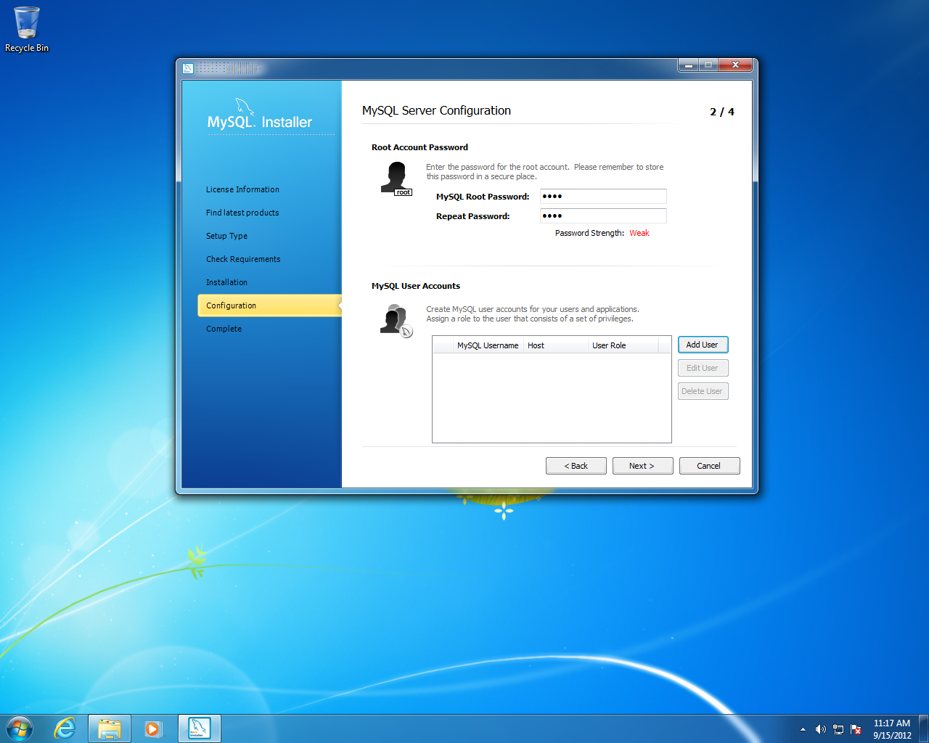

This page also gives you an option to Add User, select it, and examine the Role drop down menu to see what role options are available: You must be able to explain why the use of groups (e.g. DCOM, DWEB etc) or Role (e.g. Power User, Admin, Basic user etc) are used?

In any DBMS, we would expect to find 2 basic utilities.

1. SQL run time environment (i.e. input/edit and execute SQL statements)
2. Administration: managing databases, users, connections, etc. Essentially displaying the contents of the data dictionary of the DBMS.

Note: there are two ways that a DBA interacts with a DBMS

1. GUI utilities
2. Command prompt

You should be able to discuss this choice? E.g. why not use GUI all of the time? Why not use command prompt all the time? When would you recommend either?

Explore the MySQL programs (either use Start Programs list or explore to the MySQL folder you installed to). You are looking for a MySQL command line client. Run it, if you find it.

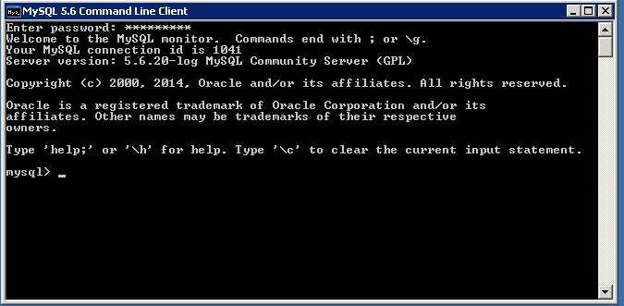

NB: this is a command line; you must terminate each line with a semi colon (;)

This client offers both SQL and Admin functionality. You must know the admin commands to use. Some of these include SHOW Databases; USE Database_name; SHOW TABLES; DESCRIBE Table_name

MySQL provides for two sample databases (Sakila, World) (installed with the server)

Using the World database perform the following SQL

* Count the number of countries in the world database?

Call the lecturer to view the result of this SQL query when you use the command line.

Find and run a GUI utility (Workbench)for administration of your server. In the Management section check that the **server logs** section. Check if the logs are visible? If not make them visible.

Display the log files

Find the My.Ini configuration file in MySQL, open it and examine its contents. What is it used for? Recall the installation paths for MySQL e.g. C:\ProgramData\ MySQL\.....

NB: MySQL may refer to this as an Options file in some contexts. NB: a file might exist but it may not be displayed!!

Write a short description of the data dictionary structure of the MySQL DBMS. Use one example that uses more than one table in an SQL Join that retrieves useful information from the data dictionary. The MySQL data dictionary is divided up into 2 databases called Information_schema and MySQL. Examine the tables in each of these to see how the meta data is organised into tables

* Use the Information_schema and display the current Processlist
* Use the MySQL and display the first three columns of the User table. (you must find out the column names)

Perform the two tasks above using both a command line and GUI

Task Check list: Your Log Wiki page should be updated with the following

* Installation of the MySQL Server package including Workbench ( if not already installed via the server package)
  + What are the MySQL installation paths for server and data?______________
* Write a note explaining why are Roles used in security/user management?
* Write a note on the differences between the Server setup types in MySQL? (Development Vs Server V’s Dedicated)
* Describe the types of Logs that are used in a DBMS? i.e. what is the function of each of the logs in MySQL?
* Can you describe why there are 2 client utilities ( command line & GUI)?
* What is the SQL select statement to find how many countries are in the world database?___________
* Using the MySQL command line, list the commands you used to do the following tasks
  + Display the current Processlist.
  + What are the first 3 columns of the User table?
* What is the MySQL data dictionary made of, how can it be processed
* What is the MySQL My.Ini file?
  + Find and open the My.Ini file and look for
    - the client section. What is the default character set?_______________________
    - the Server section: what is the server type number?
    - The MySQLD section: what is the SQL mode?
* Why are some MySQL files hidden?
  + How did you display the hidden files?